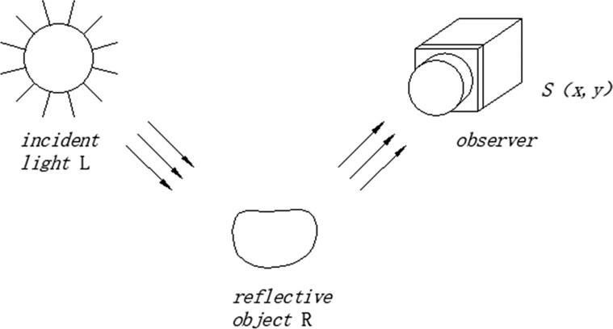As shown in the figure below, the image S of the object seen by the observer is obtained by reflecting the incident light L on the surface of the object, and the reflectance R is determined by the object itself and is not subject to changes in the incident light L.

$$S\left(x,y\right)=L\left(x,y\right)*R(x,y)$$